Unit 5
Move Well, Live Well!

Unit Theme: Movement is the foundation of lifelong vitality. This unit explores how integrating strength, flexibility, endurance, and recovery enhances physical performance, mental balance, and overall well-being.

Setting the Stage
Every movement—from a simple breath to a complex athletic performance—depends on the harmony of body systems working together. Exercise is not merely about appearance or competition; it is a science of motion that connects physiology, nutrition, and mindset. Understanding how the body adapts to activity, responds to stress, and heals from strain allows us to train smarter, prevent injury, and sustain energy throughout life. Whether you are a casual exerciser, athlete, or health professional, learning to move with awareness and purpose is central to achieving lifelong wellness.

What You Will Learn
By the end of this unit, you will be able to:
• Explain how physical activity influences wellness, stress reduction, and energy balance.
• Identify the physiological components and benefits of fitness.
• Demonstrate proper posture, form, and breathing techniques to improve movement efficiency.
• Apply principles of training, flexibility, and recovery to enhance performance and prevent injury.
• Evaluate how movement patterns and lifestyle habits contribute to long-term musculoskeletal and metabolic health.

Self-Reflection
Reflect on how your daily movement, posture, and breathing habits reveal your current state of well-being. What would it mean for you to truly “move well,” and how might that transform how you live and feel in your body?

Chapter 11: Fitness & Wellness Foundations
Chapter Outline
Section 11.1: Wellness & Stress
Section 11.2: Importance of Physical Activity
Section 11.3: Low, Moderate, and Extreme Impact Activities
Section 11.4: Physical Fitness Physiology
Section 11.5: Fitness Components
Chapter 12: Physical Activity in Practice
Chapter Outline
Section 12.1: Proper Posture, Form, & Technique
Section 12.2: The Science of Breathing
Section 12.3: Purpose of Activity
Section 12.4: Energy Balance
Section 12.5: Water & Exercise
Chapter 13: Training for Growth & Performance
Chapter Outline
Section 13.1: Fitness Assessments
Section 13.2: Strength & Core
Section 13.3: Muscle Growth & Principles
Section 13.4: Nutrient Timing
Section 13.5: Muscular Fitness
Section 13.6: Aerobic Fitness
Section 13.7: Flexibility Benefits

Chapter 14: Injury, Recovery, & Longevity
Chapter Outline
Section 14.1: Recovery Importance
Section 14.2: Mistakes & Injuries
Section 14.3: Protecting Your Back

Unit 5
Move Well, Live Well!

Chapter 11
Fitness & Wellness Foundations

Chapter Outline
Section 11.1: Wellness & Stress
Section 11.2: Importance of Physical Activity
Section 11.3: Low, Moderate, and Extreme Impact Activities
Section 11.4: Physical Fitness Physiology
Section 11.5: The Five Fitness Components

Purpose
The purpose of this unit is to deepen understanding of how movement, exercise, and stress management contribute to total wellness. Students will explore how physical activity affects both structure and function in the body—linking the science of movement with the art of healthy living. By connecting physiological processes to behavioral and emotional well-being, this unit encourages a holistic view of fitness as an essential element of a long, healthy, and fulfilling life.
This chapter reinforces the concept that movement is not only about performance but about sustainability—helping individuals move well throughout every stage of life.

Learning Outcomes
• Define wellness and describe how stress influences physical and mental health.
• Explain the importance of regular physical activity for maintaining metabolic, cardiovascular, and musculoskeletal health.
• Describe the body’s energy systems (aerobic and anaerobic) and how they fuel different forms of exercise.
• Identify and differentiate the five components of health-related fitness: cardiovascular fitness, muscular strength, muscular endurance, flexibility, and body composition.
• Apply the principles of fitness and movement science to develop a personalized wellness plan that balances exercise, nutrition, and stress management.
• Evaluate how lifestyle choices impact long-term health outcomes and overall quality of life.

Self-Reflection
Take a moment to consider what moving well means to you right now. Is it having energy for long days, performing better in your sport, or feeling strong and confident? How might that definition change as your life and priorities evolve? Reflect on whether your daily habits support or drain your physical wellness. Notice how your body responds to stress—does it tense up, slow down, or crave movement? Think of one activity you enjoy, like dancing, lifting, hiking, or walking, and how it boosts your body and mood. Finally, identify which of the five fitness components—cardiovascular endurance, muscular strength, muscular endurance, flexibility, or body composition—needs attention, and choose one small step to improve it this semester.

Section 11.1: Wellness & Stress
Understanding Wellness and Stress
Stress is an inevitable part of life. It can serve as both a motivating force and a potential threat to wellness, depending on how it is perceived and managed. Hans Selye, often referred to as the “father of stress research,” defined stress as “the nonspecific response of the body to any demand placed upon it” (Selye, 1976). This means the body reacts physiologically to both positive and negative challenges in similar ways, releasing hormones such as cortisol and adrenaline to prepare for action.
While short-term stress (acute stress) can enhance performance and focus, chronic stress—when prolonged without adequate recovery—can disrupt homeostasis, impair immunity, and increase the risk for chronic diseases such as hypertension, cardiovascular disease, and depression (McEwen, 2007). In a fast-paced society, unmanaged stress has become a key factor influencing overall wellness among Americans.
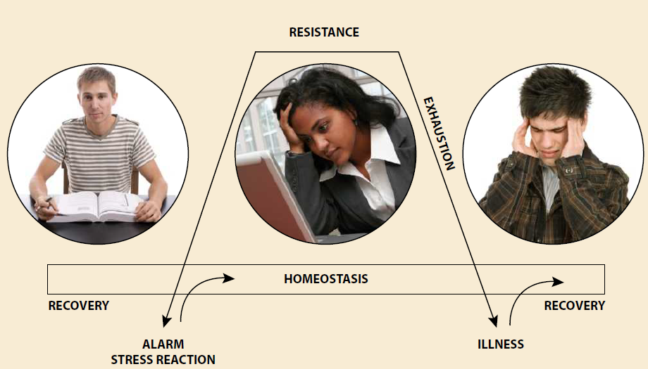
Stress Management Determines Overall Physical & Emotional Well-Being
Hugo Silveirinha Felix, 2009, Shutterstock, Inc.
Rob Marmion, 2009, Shutterstock, Inc.
Rui Vale de Sousa, 2009, Shutterstock, Inc.

Types of Stress: Eustress and Distress
Stress is not inherently harmful; in fact, moderate levels can promote growth, focus, and motivation. This positive form of stress is known as eustress. Examples include preparing for an important exam, competing in sports, or starting a new job—situations that challenge one’s abilities but also build resilience (Quick et al., 2017).
Conversely, distress refers to negative, harmful stress that exceeds one’s ability to cope. Chronic distress can result from ongoing financial strain, work overload, or personal loss. Left unmanaged, it can manifest as sleep problems, anxiety, digestive issues, or weakened immunity (APA, 2023). Recognizing the difference between eustress and distress allows individuals to approach challenges with awareness and balance.

Physiological and Emotional Responses to Stress
When faced with a stressor, the body activates the fight-or-flight response, governed by the hypothalamic-pituitary-adrenal (HPA) axis. Adrenaline increases heart rate and blood pressure, while cortisol mobilizes glucose to fuel energy demands. Once the stressor passes, the body seeks to restore homeostasis (Sapolsky, 2004).
However, when stressors persist, the body may enter a prolonged state of tension. Emotional manifestations such as irritability, mood swings, or feelings of helplessness are common. Physically, individuals may experience headaches, digestive problems, muscle tension, or cardiovascular strain. Chronic activation of the HPA axis contributes to “allostatic load,” the cumulative wear and tear on the body’s systems (McEwen, 2007).

Common Manifestations of Stress
Type of Stress Response | Common Signs and Symptoms
Emotional | • Feeling constantly rushed or overwhelmed  • Difficulty relaxing or unwinding  • Irritability, mood swings, or anger  • Feelings of helplessness or hopelessness  • Unexplained urge to cry  • Trouble focusing during conversations  • Difficulty falling or staying asleep—even when exhausted
Mental | • Indecisiveness in everyday life  • Difficulty concentrating  • Recurring bad dreams or nightmares  • Persistent negative or suicidal thoughts
Behavioral | • Noticeable changes in appetite or weight  • Neglect of personal care or appearance  • Withdrawal from social activities  • Increased use of substances (e.g., tobacco, drugs, alcohol, or caffeine)
Physical | • Elevated heart rate or blood pressure  • Awareness of heartbeat or palpitations  • Shortness of breath or chest tightness  • Frequent headaches or muscle tension  • Digestive issues (e.g., nausea, diarrhea)  • Recurring infections such as colds or sore throats

Coping and Stress Management
Effective stress management involves both problem-focused and emotion-focused strategies.
• Problem-focused coping targets the source of stress directly—such as resolving a conflict or improving time management.
• Emotion-focused coping helps manage one’s response to stress through relaxation, mindfulness, or social support (Lazarus & Folkman, 1984).

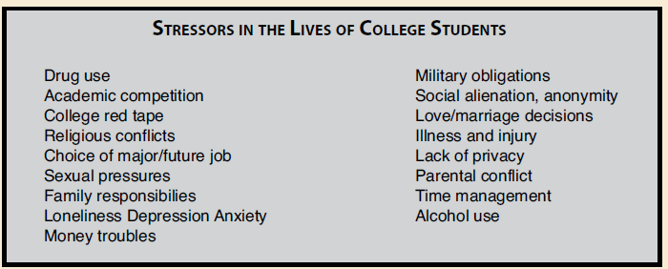

Practical approaches include:
• Regular exercise to release endorphins
• Adequate sleep and nutrition
• Building strong social connections
• Practicing mindfulness or meditation
• Positive self-talk and reframing negative thoughts
Learning to view stress as a challenge rather than a threat can improve psychological resilience and health outcomes.
Stressors in the Lives of College Students
Source: From Health and Fitness: A Guide to a Healthy Lifestyle, 5/e by Laura Bounds, Gayden Darnell, Kirstin Brekken Shea, and Dottiede Agnore. Adapted from T. H. Holmes and R. H. Rahe, 1967, Journal of Psychosomatic Research, 11:213.

Did You Know?
College students often report some of the highest perceived stress levels of any population group. According to the ACHA (2023), over 60% of students reported experiencing “overwhelming anxiety” and 40% reported feeling “so depressed it was difficult to function” in the past year. Time management and social support are key buffers against academic stress.

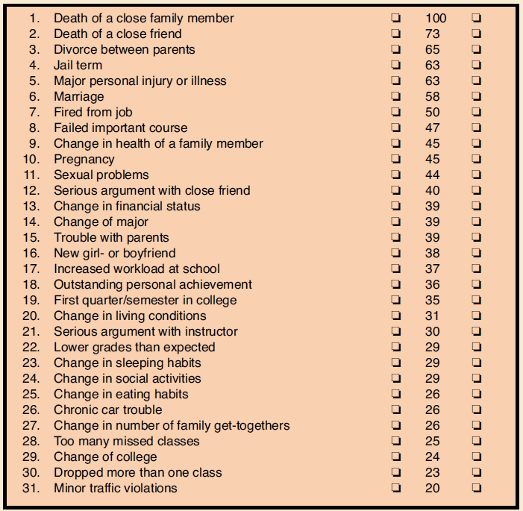##
Student Stress Scale
Source: From Health and Fitness: A Guide to a Healthy Lifestyle, 5/e by Laura Bounds, Gayden Darnell, Kirstin Brekken Shea, and Dottiede Agnore. Adapted from T. H. Holmes and R. H. Rahe, 1967, Journal of Psychosomatic Research, 11:213.

Case Study: Balancing the Load
Janelle, a first-year nursing student, juggles coursework, part-time work, and family responsibilities. Over time, she begins to experience headaches, fatigue, and irritability. After meeting with her advisor, Janelle starts incorporating short mindfulness sessions between classes, schedules weekly gym workouts, and limits her work hours. Within weeks, her energy levels improve, and she feels more in control.
This case highlights how self-awareness and proactive coping can prevent stress from turning into distress.

Reflection
1. How do you typically respond to stressful situations—emotionally, mentally, or behaviorally?
2. What are three specific coping techniques that could help you manage daily stress more effectively?
3. How can eustress contribute to your personal growth and academic success?

Discussion
Discuss how social and environmental factors (e.g., family, peers, work culture) influence the way individuals experience and manage stress. How can colleges and communities better support mental wellness?

Section 11.2: Importance of Physical Activity

The Role of Physical Activity in Total Wellness
Physical activity is one of the most critical components of overall health and wellness. While many people approach exercise primarily as a tool for weight management, this narrow focus often overlooks the broader physiological and psychological benefits of movement. According to the Centers for Disease Control and Prevention (CDC, 2023), regular physical activity reduces the risk of chronic diseases, enhances mood, improves sleep, and strengthens the musculoskeletal and cardiovascular systems.
Weight loss goals may motivate short-term engagement in physical activity, but long-term adherence comes from recognizing exercise as a lifestyle practice that sustains energy, mobility, and mental balance. Individuals who integrate movement into their daily lives for stress relief, emotional regulation, or physical endurance often experience greater overall wellness and a more sustainable relationship with their bodies (WHO, 2020).

Redefining the Purpose of Physical Activity
Many people associate physical activity with “working off” excess weight or calories. This weight-centered mindset can make exercise feel like punishment rather than empowerment. In contrast, a wellness-centered mindset views physical activity as a tool for strengthening the body, supporting mental clarity, and improving quality of life.
Occupational and daily functional activities—such as walking, lifting, or cleaning—also contribute to physical fitness. Research suggests that non-exercise activity thermogenesis (NEAT)—the energy expended in daily movement outside of structured exercise—can significantly impact metabolic health and body composition (Levine, 2004). This means that even individuals who do not frequent a gym may still be achieving meaningful physical fitness through their active lifestyles.
By reframing exercise as a mechanism to withstand, maintain, and build one’s lifestyle and career rather than a means of altering physical appearance, individuals can develop more positive, intrinsic motivation. Exercise becomes not just a tool for aesthetic goals but a foundation for longevity, resilience, and vitality.

Physical Activity and Mental Health
Beyond physical strength and endurance, regular activity profoundly impacts mental health. Aerobic exercise stimulates the release of endorphins and serotonin—neurotransmitters that reduce symptoms of anxiety and depression (Mayo Clinic, 2023). Engaging in consistent physical movement has been associated with improved self-esteem, cognitive function, and emotional regulation.
Additionally, physical activity can serve as a form of psychological relief—a way to process stress, clear the mind, and promote mindfulness through motion. Individuals who approach exercise with this perspective often find that movement becomes a form of therapy rather than obligation.

Nutrition and Physical Activity: A Complementary Relationship
Exercise and nutrition are interdependent. Physical activity supports nutrient metabolism, improves insulin sensitivity, and aids digestion. Meanwhile, adequate nutrition provides the energy and micronutrients necessary for muscle repair, hormone regulation, and recovery (Gropper & Smith, 2021).
In this way, exercise is not simply a counterbalance to caloric intake—it is a biological partner to nutrition that supports total metabolic health. Viewing physical activity as a supplement to nutrition rather than a punishment for eating fosters a sustainable and balanced approach to wellness.

Did You Know?
The World Health Organization (2020) recommends at least 150 minutes of moderate-intensity or 75 minutes of vigorous-intensity physical activity per week for adults. Yet, more than one in four adults globally do not meet these minimum guidelines—contributing to over 5 million preventable deaths annually from inactivity-related diseases.

Case Study: Redefining Fitness Goals
Marcus, a 35-year-old warehouse worker, walks an average of 12,000 steps per day and regularly lifts heavy boxes. Despite being physically active at work, he feels fatigued and discouraged by his lack of “gym time.” After consulting a wellness coach, Marcus learns to recognize his daily movement as meaningful exercise. He begins supplementing his routine with stretching and weekend bike rides rather than overexerting himself at the gym. Within weeks, his energy and mood improve—illustrating how reframing physical activity can promote both physical and mental well-being.

Reflection
1. How do you currently define physical activity in your life—by movement, weight loss, or overall wellness?
2. In what ways does your occupation or daily routine contribute to your physical fitness?
3. How can you reframe your mindset to view exercise as a source of strength and balance rather than obligation?

Discussion
Discuss the cultural and social influences that shape how people perceive physical fitness. How might shifting from a “weight-centered” to a “wellness-centered” model impact public health outcomes?

Section 11.3: Low, Moderate, and Extreme Impact Activities

Structure, Function, and Purpose of Movement Intensity
Everyday life involves a spectrum of physical activities—some intentional, others subconscious—that collectively contribute to cardiovascular endurance, muscular strength, flexibility, and mental well-being. These activities can be categorized as low, moderate, or high (extreme) impact, depending on their effect on heart rate, oxygen consumption, and muscle exertion (ACSM, 2021).
Understanding the differences among these intensity levels helps individuals select appropriate activities that align with their abilities, health status, and goals. From a structural perspective, all forms of movement engage skeletal muscles and energy metabolism. Functionally, they strengthen the cardiovascular and respiratory systems, regulate metabolism, and maintain musculoskeletal health. Purposefully, they enhance longevity, resilience, and stress management—supporting both physical and psychological wellness.

Low-Impact Activities
Low-impact activities are gentle on the joints and require minimal energy expenditure but still stimulate circulation, flexibility, and muscle tone. These activities include leisurely walking, light household chores, yoga, stretching, and even playful movement such as dancing at a relaxed pace. Activities such as walking along the lakefront, gardening, or carrying groceries also fall into this category.
From a physiological standpoint, these activities modestly elevate heart rate and promote blood flow without overloading the body. They are especially beneficial for beginners, older adults, or individuals recovering from injury (NIH, 2022). Low-impact movement promotes consistency, mobility, and recovery—making it foundational for long-term wellness.

Moderate-Impact Activities
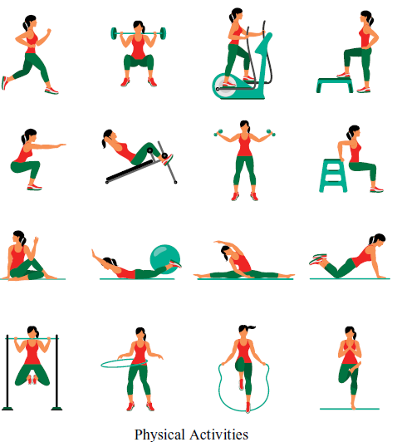
Moderate-impact activities elevate the heart rate and breathing more noticeably while still allowing for conversation. Examples include brisk walking, cycling at 10–15 mph, recreational swimming, or dancing at an energetic pace. These activities strengthen the heart and lungs, improve metabolic efficiency, and support healthy body composition (CDC, 2023).
The World Health Organization (2020) recommends at least 150 minutes of moderate-intensity physical activity per week to reduce the risk of cardiovascular disease, diabetes, and depression. Functionally, this level of activity enhances endurance and improves the body’s ability to utilize oxygen—key components of aerobic fitness.
Different Types of Physical Activities
Dmitriy Samorodinov/Shutterstock.com

High (Extreme) Impact Activities
High- or extreme-impact activities significantly raise heart rate and challenge muscular and cardiovascular endurance. These include running, martial arts, uphill hiking, plyometrics, and high-intensity interval training (HIIT). Such exercises may fatigue the body within minutes but promote substantial physiological adaptation when performed safely and progressively (Mayo Clinic, 2023).
Extreme-impact exercises enhance anaerobic capacity, muscle hypertrophy, and bone density. However, due to their intensity, these activities require proper technique, hydration, and recovery to prevent injury or overtraining. The purpose of high-impact training is to push physical limits—developing strength, speed, and resilience.

Integrating Activity Levels into Daily Life
The diversity of physical activities available allows individuals to tailor their fitness regimens according to lifestyle, environment, and personal preference. A balanced program combines low, moderate, and high-impact movements to promote cardiovascular health, muscular endurance, flexibility, and stress relief.
Crucially, even routine daily tasks—such as walking at work, cleaning, or climbing stairs—contribute to overall energy expenditure and metabolic health. This reinforces the idea that all movement matters. Consistency in physical activity, regardless of intensity, supports cellular maintenance, growth, and repair—essential processes for health and longevity (Gropper & Smith, 2021).

Levels of Physical Activity and Their Characteristics
Activity Level | Description | Examples | Physiological Benefits | Best Suited For
Low-Impact Activities | Gentle on the joints and require minimal energy expenditure, yet support circulation, flexibility, and muscle tone. Promote consistent, sustainable movement for long-term wellness. | • Leisurely walking  • Yoga or stretching  • Light chores or gardening  • Relaxed dancing  • Carrying groceries | • Improves blood flow and mobility  • Enhances flexibility and recovery  • Maintains joint health | • Beginners  • Older adults  • Individuals recovering from injury
Moderate-Impact Activities | Increase heart rate and breathing while allowing conversation. Strengthen the heart and lungs and support healthy body composition. | • Brisk walking  • Recreational swimming  • Cycling (10–15 mph)  • Energetic dancing | • Improves cardiovascular endurance  • Boosts metabolic efficiency  • Enhances aerobic fitness | • Most adults seeking general fitness  • Individuals managing weight or stress
High (Extreme) Impact Activities | Significantly raise heart rate and challenge muscular and cardiovascular endurance. Require progressive training and proper recovery. | • Running  • Martial arts  • HIIT or plyometrics  • Uphill hiking | • Increases anaerobic capacity  • Builds muscle and bone strength  • Enhances speed and power | • Trained or conditioned individuals  • Athletes building performance capacity

Did You Know?
According to the ACSM (2021), every minute of high-intensity exercise can provide benefits equivalent to roughly two minutes of moderate activity. However, overtraining without proper rest can impair immune function and muscle recovery.

Reflection
1. Which types of physical activity—low, moderate, or high impact—best fit your current lifestyle and goals?
2. How can you modify your daily routine to integrate more movement without formal exercise?
3. Reflect on how your motivation for physical activity has changed over time—what drives you today?

Section 11.4: Physical Fitness Physiology

Structure, Function, and Purpose
The human body is a complex biological machine powered by chemical energy. Understanding how it produces, uses, and conserves this energy is essential for optimizing physical performance, endurance, and recovery. Every movement—from walking to sprinting—relies on the conversion of nutrients into usable energy in the form of ATP.
Structurally, energy production involves multiple organ systems: the muscular, cardiovascular, and respiratory systems working together to deliver fuel and oxygen to tissues. Functionally, the body uses three energy systems—phosphagen, glycolytic, and oxidative (aerobic)—to generate ATP based on activity intensity and duration. Purposefully, this coordination allows humans to adapt, perform, and sustain physical activity efficiently across varying levels of demand (Kenney et al., 2021; McArdle et al., 2022).

Energy Systems Provide the Fuel for Exercise
ATP is often referred to as the “energy currency” of the body. Like gasoline in a car, it powers all muscular contractions and physiological work. The body synthesizes ATP through the breakdown of carbohydrates and fats, with proteins used primarily when energy demands are extreme or nutrient intake is inadequate.

Aerobic Metabolism (“With Oxygen”)
Aerobic metabolism is the body’s primary and most efficient energy system, using oxygen to generate ATP from glucose, glycogen, and fatty acids. This system becomes dominant during prolonged activities lasting longer than five minutes—such as cycling, swimming, or distance running.
Energy production occurs in the mitochondria, the “power plants” of cells, through mitochondrial respiration. Although fats can provide abundant energy, their breakdown is slower than that of carbohydrates. When glycogen stores are depleted, fatigue and reduced performance follow (Brooks et al., 2023).

Anaerobic Metabolism (“Without Oxygen”)
Anaerobic metabolism provides rapid bursts of ATP without oxygen. It dominates during high-intensity or short-duration efforts such as sprinting, weightlifting, or jumping. There are two primary anaerobic pathways:
1. Phosphagen System (ATP–PCr System): Uses creatine phosphate stored in muscles to quickly regenerate ATP for immediate, explosive energy—typically lasting 10–15 seconds.
2. Glycolytic System (Anaerobic Glycolysis): Breaks down glucose to produce ATP without oxygen, yielding lactic acid as a byproduct. This process supports high-intensity effort lasting up to 2 minutes.
Although efficient in the short term, anaerobic metabolism leads to accumulation of hydrogen ions (H⁺) and lactate, contributing to muscle fatigue and the sensation known as “the burn.” Contrary to older research, it is the hydrogen ions—not lactate itself—that cause acidosis and fatigue (Robergs et al., 2004).

The Cardiorespiratory System Delivers the Oxygen
The cardiorespiratory system—comprising the heart, lungs, and blood vessels—ensures that oxygen is transported efficiently to working muscles. It consists of two components:
• Central Component: The heart and lungs, which deliver oxygen to the bloodstream.
• Peripheral Component: The muscles and capillaries that extract and use oxygen for ATP production.
Consistent aerobic training enhances both components, increasing stroke volume (the amount of blood pumped per beat), lung capacity, and capillary density in muscle tissue (NIH, 2023). This results in greater endurance, improved performance, and faster recovery.

The Muscular System: The Engines That Do the Work
Skeletal muscles act as the engines of movement, converting chemical energy into mechanical work. Each muscle fiber contracts in response to signals from the nervous system, which coordinates voluntary movement. Muscles operate in pairs—one contracting while the opposing one relaxes—to create smooth, controlled motion. During sustained exercise, muscles draw on oxygen and nutrients to generate ATP continuously. This process produces heat, which is released through sweating and increased respiration rate—critical for temperature regulation. Hydration before, during, and after exercise supports this thermoregulation process and prevents performance decline (Mayo Clinic, 2024).

Did You Know?
The human body stores only enough ATP for about 2–3 seconds of maximum effort. After that, your energy systems must continuously regenerate ATP to sustain activity (Kenney et al., 2021).

Reflection
1. When you exercise, which energy system do you rely on most frequently, and how do you know?
2. How does understanding ATP metabolism change your perception of endurance vs. strength training?
3. Reflect on your body’s signals during exercise—what does fatigue teach you about your energy systems?

Discussion
Discuss how training methods (e.g., endurance vs. strength vs. high intensity) target different energy systems. How might this knowledge help professionals design personalized fitness or rehabilitation programs?

Section 11.5: The Five Fitness Components

Introduction
Health-related fitness refers to physical capacities that directly contribute to the prevention of chronic disease, maintenance of functional independence, and enhancement of overall well-being. Unlike skill-related fitness, which supports athletic performance, health-related fitness is essential for everyday functioning and long-term health outcomes (CDC, 2023). The five components of health-related fitness are cardiovascular fitness, muscular strength, muscular endurance, flexibility, and body composition. Together, these elements form the foundation of physical health and determine how effectively the body performs work, recovers from exertion, and resists injury or disease.

Five components of health-related fitness:
1. cardiovascular fitness,
2. muscular strength,
3. muscular endurance,
4. flexibility, and
5. body composition.
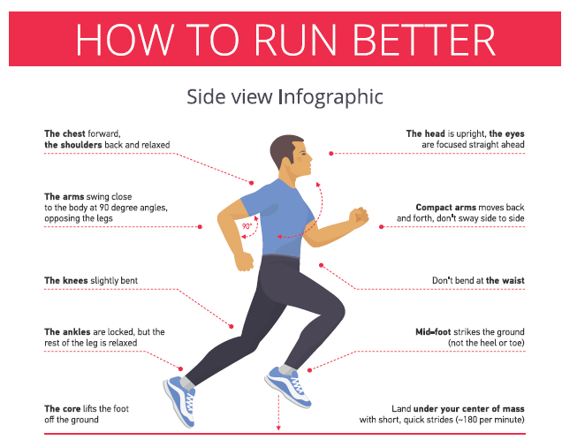

Cardiovascular Fitness
Cardiovascular fitness—also called cardiorespiratory endurance—is the ability of the heart, lungs, and circulatory system to deliver oxygen-rich blood to working muscles during sustained physical activity. Activities such as running, cycling, and swimming challenge this system, improving its efficiency and resilience over time.
Aerobic exercise (meaning “with oxygen”) strengthens the heart muscle, enhances lung capacity, and increases the body’s ability to utilize oxygen efficiently (ACSM, 2021). Improved cardiovascular fitness has been shown to reduce the risk of hypertension, stroke, and coronary heart disease (Piercy et al., 2018).
peart.ru/Shutterstock.com

Muscular Strength
Muscular strength is the maximal force a muscle or muscle group can generate during a single effort—such as lifting a heavy weight. Strength training improves bone density, metabolism, and joint stability, while also helping to prevent age-related muscle loss (sarcopenia). Progressive resistance training has been linked to improved glucose metabolism, better posture, and enhanced quality of life among older adults (Westcott, 2012).

Muscular Endurance
While muscular strength focuses on how much force a muscle can exert at once, muscular endurance emphasizes how long it can perform repeated contractions before fatigue sets in. Endurance training—such as rowing, cycling, or circuit workouts—promotes efficient oxygen delivery to muscles, enabling sustained activity (Kenney et al., 2021). Improved muscular endurance is critical for activities of daily living, such as climbing stairs, carrying groceries, or maintaining posture throughout the day.

Flexibility
Flexibility refers to the range of motion available at a joint or series of joints. Adequate flexibility supports movement efficiency, reduces the risk of injury, and improves functional mobility—particularly important as we age (ACSM, 2021). Stretching, yoga, and dynamic warm-ups all contribute to improved flexibility by maintaining elasticity of muscles and tendons.

Body Composition
Body composition describes the proportion of fat mass to lean mass (muscle, bone, water, and organs) in the body. Optimal body composition supports metabolic efficiency, cardiovascular function, and musculoskeletal health (Heymsfield et al., 2015). Regular exercise combined with balanced nutrition promotes a healthier ratio of lean tissue to fat, reducing the risk of obesity-related diseases such as type 2 diabetes and cardiovascular disorders.

Did You Know?
A study from the Journal of the American Heart Association found that individuals with high cardiovascular fitness have up to 70% lower risk of all-cause mortality compared to those with low fitness levels—regardless of body weight (Blair et al., 2019).
In short: Fitness may matter more for long-term health than body size alone.

Case Study: Reclaiming Health Through Functional Fitness
Maria, a 52-year-old office manager, struggled with fatigue and back pain after years of sedentary work. After joining a local fitness class that integrated aerobic, resistance, and flexibility training, Maria improved her cardiovascular endurance and core strength within 12 weeks. Her physician noted lower blood pressure and improved glucose levels. Maria reports that she can now climb stairs without exhaustion—demonstrating how balanced physical fitness directly enhances quality of life.
Which component of health-related fitness was most critical in Maria’s improvement, and why?

Reflections
• How might improving one component of health-related fitness influence the others?
• Which component do you think most directly affects longevity, and why?
• What strategies could you adopt to enhance your weakest fitness component this semester?

Discussion
1. Compare and contrast cardiovascular fitness and muscular endurance. How do these systems interact during exercise?
2. Discuss how body composition can impact performance and long-term health outcomes.
3. Why is flexibility often underestimated, and how can it be better integrated into daily routines?
4. In what ways can technology (e.g., fitness trackers, smartwatches) support balanced fitness development?

Summary
The five components of health-related fitness—cardiovascular fitness, muscular strength, muscular endurance, flexibility, and body composition—work together to promote optimal physical function and prevent disease. Regular participation in varied physical activities can enhance each component, contributing to improved health outcomes, functional independence, and psychological well-being across the lifespan.

Key Terms
Key Term | Definition
Aerobic Exercise | Physical activity that depends on oxygen for sustained energy production and improves endurance and cardiovascular health (WHO, 2020).
Aerobic Metabolism | Energy production that requires oxygen, primarily using fats and carbohydrates for prolonged exercise.
Allostatic Load | The cumulative “wear and tear” on the body resulting from chronic stress and repeated adaptation (McEwen, 2007).
Anaerobic Exercise | Short, intense activity relying on energy sources within the muscles, such as sprinting or weightlifting (ACSM, 2021).
Anaerobic Metabolism | Energy production without oxygen, used for short bursts of high-intensity effort.
Body Composition | The ratio of fat mass to lean mass (muscle, bone, and tissue) in the body.
Cardiorespiratory System | The heart, lungs, and blood vessels responsible for oxygen delivery and carbon dioxide removal.
Cardiovascular Fitness | The ability of the heart, lungs, and blood vessels to deliver oxygen efficiently to working muscles.
Distress | Negative stress that occurs when demands exceed coping resources, leading to mental or physical strain (APA, 2023).
Endorphins | Neurochemicals released during physical activity that promote pain relief and feelings of well-being (Mayo Clinic, 2023).
Energy Expenditure | The total amount of energy used by the body during physical activity and rest (Gropper & Smith, 2021).
Eustress | Positive stress that enhances motivation, focus, and performance when managed effectively (Quick et al., 2017).
Flexibility | The range of motion available at a joint or group of joints, influenced by muscle length and joint structure.
High-Impact (Extreme) Activity | Exercise that substantially increases heart rate and muscle demand, enhancing strength and anaerobic capacity (Mayo Clinic, 2023).
Homeostasis | The body’s ability to maintain internal stability despite external changes (Sapolsky, 2004).
Hydrogen Ion (H⁺) Accumulation | A byproduct of glycolysis that contributes to acidosis and muscular fatigue.
Intrinsic Motivation | The drive to engage in an activity for internal satisfaction rather than external reward (Deci & Ryan, 2000).
Lactate | A byproduct of anaerobic metabolism that also serves as an energy shuttle in the body.
Low-Impact Activity | Movement that places minimal stress on joints while promoting flexibility, balance, and circulation (NIH, 2022).
Metabolism (Aerobic & Anaerobic) | The chemical processes in cells that convert nutrients into energy, with or without oxygen.
Mitochondria | The cell’s “powerhouses” that produce ATP through aerobic metabolism.
Moderate-Impact Activity | Activity that raises heart rate and breathing but still allows conversation; improves endurance and cardiovascular health (CDC, 2023).
Muscular Endurance | The ability of muscles to perform repeated contractions over time without fatigue.
Muscular Strength | The maximum force that a muscle or group of muscles can exert in a single contraction.
Non-Exercise Activity Thermogenesis (NEAT) | The energy expended from daily activities other than structured exercise, such as walking or cleaning (Levine, 2004).
Phosphagen System (ATP–PCr System) | Immediate energy system that uses creatine phosphate to rapidly regenerate ATP.
Physical Activity | Any bodily movement produced by skeletal muscles that results in energy expenditure (WHO, 2020).
Physical Fitness | A set of attributes—such as endurance, strength, and flexibility—that enable effective performance of physical tasks (ACSM, 2021).
Sarcopenia | The age-related loss of skeletal muscle mass and strength.
Stress | The nonspecific physiological and psychological response of the body to any demand or challenge (Selye, 1976).
Thermoregulation | The body’s ability to maintain internal temperature through sweating and blood flow.

References
American College Health Association (ACHA). (2023). National College Health Assessment: Undergraduate Student Reference Group Executive Summary. Silver Spring, MD.
American College of Sports Medicine (ACSM). (2021). ACSM’s guidelines for exercise testing and prescription (11th ed.). Wolters Kluwer.
American Psychological Association (APA). (2023). Stress in America 2023: The state of our nation. Washington, DC: Author.
Blair, S. N., Kampert, J. B., Kohl, H. W., et al. (2019). Influences of cardiorespiratory fitness and other precursors on cardiovascular disease and all-cause mortality. Journal of the American Heart Association, 8(3), e010986. https://doi.org/10.1161/JAHA.118.010986
Brooks, G. A., Fahey, T. D., & Baldwin, K. M. (2023). Exercise physiology: Human bioenergetics and its applications (6th ed.). McGraw-Hill Education.
Centers for Disease Control and Prevention (CDC). (2023). Physical activity basics. U.S. Department of Health and Human Services. https://www.cdc.gov/physicalactivity
Deci, E. L., & Ryan, R. M. (2000). The “what” and “why” of goal pursuits: Human needs and the self-determination of behavior. Psychological Inquiry, 11(4), 227–268. https://doi.org/10.1207/S15327965PLI1104_01
Gropper, S. S., & Smith, J. L. (2021). Advanced nutrition and human metabolism (7th ed.). Cengage Learning.
Heymsfield, S. B., Peterson, C. M., Thomas, D. M., Heo, M., & Schuna, J. M. (2015). Human body composition: Advances in models and methods. Annual Review of Nutrition, 35(1), 19–43. https://doi.org/10.1146/annurev-nutr-071714-034322
Kenney, W. L., Wilmore, J. H., & Costill, D. L. (2021). Physiology of sport and exercise (8th ed.). Human Kinetics.
Lazarus, R. S., & Folkman, S. (1984). Stress, appraisal, and coping. Springer.
Levine, J. A. (2004). Non-exercise activity thermogenesis (NEAT). Best Practice & Research Clinical Endocrinology & Metabolism, 16(4), 679–702. https://doi.org/10.1016/j.beem.2004.07.004
Mayo Clinic. (2023). Exercise and stress: Get moving to manage stress. Mayo Foundation for Medical Education and Research. https://www.mayoclinic.org/healthy-lifestyle/stress-management/in-depth/exercise-and-stress/art-20044469
Mayo Clinic. (2023). Exercise intensity: How to measure it. Mayo Foundation for Medical Education and Research. https://www.mayoclinic.org/healthy-lifestyle/fitness/in-depth/exercise-intensity/art-20046887
Mayo Clinic. (2024). Hydration and exercise: Why it matters. Mayo Foundation for Medical Education and Research. https://www.mayoclinic.org/healthy-lifestyle/fitness/in-depth/water/art-20044256
McArdle, W. D., Katch, F. I., & Katch, V. L. (2022). Exercise physiology: Nutrition, energy, and human performance (9th ed.). Wolters Kluwer.
McEwen, B. S. (2007). Physiology and neurobiology of stress and adaptation: Central role of the brain. Physiological Reviews, 87(3), 873–904. https://doi.org/10.1152/physrev.00041.2006
National Institutes of Health (NIH). (2022). Benefits of physical activity. National Heart, Lung, and Blood Institute. https://www.nhlbi.nih.gov/health-topics/physical-activity
National Institutes of Health (NIH). (2023). Physical activity and your heart. National Heart, Lung, and Blood Institute. https://www.nhlbi.nih.gov/health/heart-physical-activity
Piercy, K. L., Troiano, R. P., Ballard, R. M., et al. (2018). The Physical Activity Guidelines for Americans, 2nd edition. Journal of the American Medical Association, 320(19), 2020–2028. https://doi.org/10.1001/jama.2018.14854
Quick, J. C., Wright, T. A., Adkins, J. A., Nelson, D. L., & Quick, J. D. (2017). Preventive stress management in organizations (2nd ed.). American Psychological Association.
Robergs, R. A., Ghiasvand, F., & Parker, D. (2004). Biochemistry of exercise-induced metabolic acidosis. American Journal of Physiology–Regulatory, Integrative and Comparative Physiology, 287(3), R502–R516. https://doi.org/10.1152/ajpregu.00114.2004
Sapolsky, R. M. (2004). Why zebras don’t get ulcers (3rd ed.). W. H. Freeman.
Selye, H. (1976). The stress of life (Rev. ed.). McGraw-Hill.
Westcott, W. L. (2012). Resistance training is medicine: Effects of strength training on health. Current Sports Medicine Reports, 11(4), 209–216. https://doi.org/10.1249/JSR.0b013e31825dabb8
World Health Organization (WHO). (2020). Global recommendations on physical activity for health. Geneva: WHO Press. https://www.who.int/publications/i/item/9789241599979
Credits
Health and Fitness: A Guide to a Healthy Lifestyle, 5/e by Laura Bounds, Gayden Darnell, Kirstin Brekken Shea, and Dottiede Agnore. Copyright © 2012 by Kendall Hunt Publishing Company. Reprinted by permission.
Anybody’s Guide to Total Fitness, 12/e by Leonard Kravitz. Copyright © 2020 by Kendall Hunt Publishing Company. Reprinted by permission.
Fitness and Your Health, 8/e by David C. Nieman. Copyright © 2016 by Kendall Hunt Publishing Company. Reprinted by permission.
An Introduction to Anatomy and Physiology, 1/e by John L Erickson. Copyright © 2010 by Kendall Hunt Publishing Company. Reprinted by permission.

END OF CHAPTER

